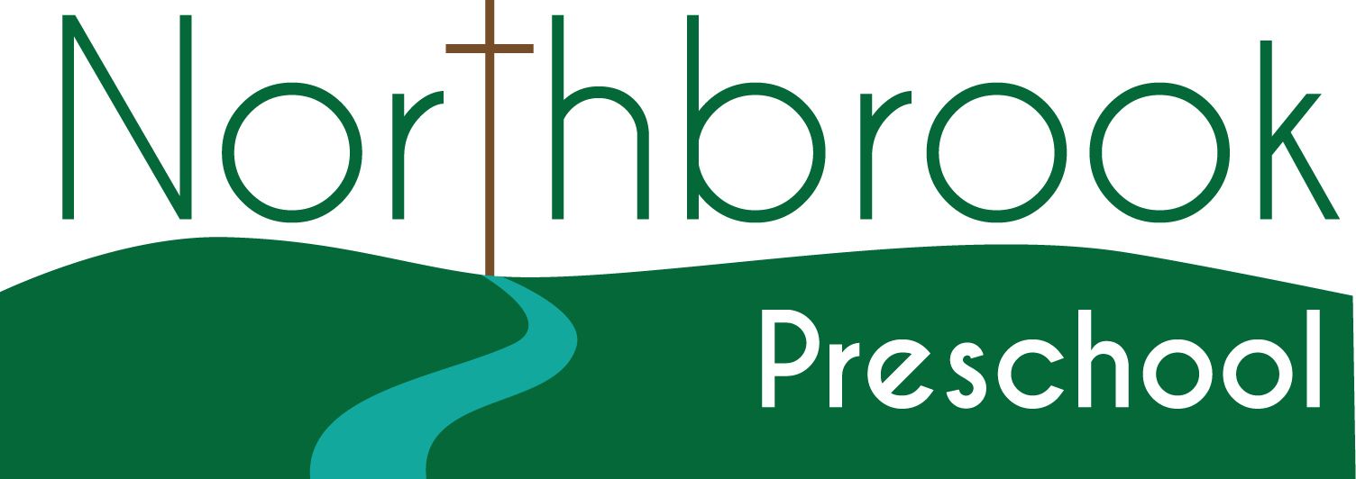
Dear Northbrook Preschool Partner/Volunteer,
You are a valuable part of our program and we appreciate what you contribute by sharing your time and talents with our children. The new law in GA requires each volunteer to take a course on recognizing and reporting child abuse. We are using the course that Fulton County Schools has developed. Please take the short course at www.fultonschools.org. You can access the course by clicking on the “Community” tab. Click on “Register as a volunteer”, then click “Click here to begin the volunteer registration application.” Complete the registration and take the course. You do NOT need to proceed to the volunteer registration form after completing the training video. Instead, we are providing you with a form to complete, certifying that you have taken this course. You enrich the children’s experiences in so many ways. We don’t want this requirement to affect your willingness to participate; however, it is state law that we must follow and it takes very little time.
In order to assist you in understanding our program and what is necessary in interacting appropriately with preschool children, we are providing you with the following information as a way of providing you with a preliminary orientation:
- Observations made about children while in the classroom are confidential and should not be discussed with other parents or anyone other than faculty and staff of the program directly associated with the children involved.
- Hands should be washed using the posted procedures at the following times:
- Upon arrival;
- After diapering or using the toilet;
- After handling bodily fluids (blowing or wiping a nose, coughing on a hand, or touching mucus, blood, or vomit);
- Before meals and snacks, before preparing or serving food, or after handling raw food that requires cooking (meat, eggs, poultry);
- After playing in water that is shared by two or more people;
- After handling pets and other animals or any materials such as sand, dirt, or surfaces that might be contaminated by contact with animals;
- When moving from a group that involves contact with toddlers/twos;
- After assisting a child with toileting
- After handling garbage or cleaning
- Emergency procedures for fire evacuation, tornado, CPR, choking and first aid are posted by the door in each room. A copy of the school Critical Incident Plan which gives directions for all types of emergencies is in the class travel bag. The teachers will direct children and volunteers in emergencies. Please follow the directions given by the lead and/or assistant teachers.
- Children should be taken to the clinic when they have a fever, diarrhea, or a runny nose that cannot be contained, have vomited or exhibit a rash.
- Corporal punishment, threats or derogatory remarks are never used with children. Withholding or threatening to withhold food as a form of discipline is never allowed.
- Children are treated with respect and children should be asked to assess their own behavior in relation to the expected standard, i.e., “What is the rule about running?” If correction must be used, the positive form is expected. For example, instead of telling a child, “Don’t run;” use the positive form of “Use your walking feet.”
- Allow children to do their own work, to participate in making their own decisions, and to solve their own problems. Resist the urge to correct children’s work by repositioning art materials or telling children exactly how to complete a project. Allow children the opportunity to solve their problems but remain aware and attentive to assisting through questioning if needed. Creativity and curiosity are best encouraged by allowing children to think and do for themselves within the boundaries and guidelines of the classroom.
- If you observe any instances of child abuse or neglect, you are a mandated reporter and must report this to the Georgia Department of Family and Children Services within 24 hours. As a courtesy we ask that you would discuss your observations with a staff member in our program so we are knowledgeable of your suspicions about abuse or neglect.
- Our program is exempt from licensure by Bright from the Start, the state regulatory agency of child care centers; however, we voluntarily meet the expectations for licensed centers. The guidelines for licensure are found at http://decal.ga.gov/documents/attachments/CCLCRulesandRegulations.pdf. A copy of this document is in the preschool office and we expect you to become familiar with the requirements.
Thank you for being a volunteer in our program. We want this to be a very valuable experience for you and for the children. It is our hope that these guidelines will assist in making you feel comfortable interacting in our program.
Sincerely,

Jennifer Picquet, Director

